**MINOR PROJECT - I**

**SYNOPSIS**

**ON**

**Comparative Analysis between Graph Traversing Algorithms to**

**Optimize Route Efficiency**

**Submitted By**

|  |  |  |  |
| --- | --- | --- | --- |
| Aaryash Raj Sinha | Suvrat Jain | Sambbhav Garg | Samarth Singh |
| R110217002 | R110217169 | R103217092 | R134217136 |

***Under the guidance of***

**Dr. Anurag Jain**

Assistant Professor - Selection Grade (SG),

Department of Virtualization

School of Computer Science



**Cloud Computing & Virtualization Technology**

**Department of Virtualization**

**School of Computer Science**

**UNIVERSITY OF PETROLEUM AND ENERGY STUDIES**

**Dehradun - 248007**

**Aug - Nov, 201**

**ABSTRACT**

As the need to develop large cities to accommodate life increases, so does the need for logistics. Suppose you own a multi-million dollar courier company, Fednex. Now, you have 100 customers in 5 different cities, and way too many factors to base upon the argument - "who gets their package first?" That's where our problem statement steps in. The solution that we're working on can help optimize routes between multiple cities using, as of now, two different algorithms. The first one is Dijkstra's algorithm, which is a single source shortest path algorithm, say all the couriers are shipped out from just one warehouse. But what if you have multiple warehouses? Well, then you use an Optimization problem, such as the Travelling Salesman problem, to minimize the routes to a set of efficient routes out of a lot of possible choices. Now suppose you have a number of employees working at your company, and you choose two nodes, say A & B. Now, there seem to be multiple ways to travel from A to B, but which one do you choose? That’s where Ant Colony Optimization comes in. Just like ants, the employees can rate routes from A to B which are better, and as time passes, better routes surface inherently.

**INTRODUCTION**

**Dijkstra’s Algorithm**

Dijkstra‘s Algorithm, created by Dutch computer scientist Edsger W. Dijkstra in 1959, is a graph traversal algorithm that solves the single-source shortest path problem for a graph with non-negative edge path costs, producing a shortest-path tree. This algorithm is often used in routing and other network related protocols.[5]

Dijkstra‘s algorithm works by solving a sub-problem k, which computes the shortest path from the source to the vertices among the k-closest vertices to the source. For Dijkstra's Algorithm to work, the graph must be a directed, weighted graph with non-negative edges. At the $k^{th}$ round, a set called ‘Frontier of k-vertices’ will consist of all vertices closest to the source. The vertices that lie outside the set are computed and put into a New Frontier. The shortest distance obtained is maintained in sDist[w]. It holds the estimate of the distance from s to w. Dijkstra‘s algorithm finds the next closest vertex by maintaining the New Frontier vertices in a priority-min queue.

A major disadvantage of Dijkstra’s algorithm is that it does a blind search; thereby consuming a wasteful lot of time, and necessary resources. Another disadvantage is that it cannot handle negative edges. Traffic information systems use Dijkstra‘s algorithm in order to track the source and destinations from a given particular source and destination. In the Link-state routing protocol approach, each router calculates the shortest path within each network and enters this information into the routing table.

**Travelling Salesman Problem**

Travelling Salesman Problem(TSP) is an NP-hard combinatorial optimization problem. The basic idea is to find a tour of a given number of nodes; to visit each node exactly once and return to the parent node and find the minimized length of this tour. If there are ‘n’ number of nodes, there would be as many as (n-1)! feasible solutions. Out of these, there would be only one minimized route.[1]

The first instance of the traveling salesman problem was from Euler in 1759 whose problem was to move a knight to every position on a chess board exactly once.The TSP problem first gained popularity from the book written by a German salesman B.F. Voigt in 1832 on how to be a successful travelling salesman. He mentions the TSP, although not by that name, by suggesting to cover as many locations as possible without visiting any location twice.

The standard or symmetric traveling salesman problem can be stated mathematically as follows:

Given a weighted graph G = (V,E) where V is the number of vertices, and E is the number of edges, the weight $C_{ij}$ on the edge between nodes i and j is a non-negative value, find the tour of all nodes that has the minimum total cost. Currently the only known method guaranteed to optimally solve the traveling salesman problem of any size, is by enumerating each possible tour and searching for the tour with the smallest cost. Each possible tour is a permutation of 1, 2, 3 . . . n, where n is the number of cities, so therefore the number of tours is n!. When n gets large, it becomes impossible to find the cost of every tour in polynomial time. Hence, is the problem.[3]

**Ant Colony Optimization**

Ants are capable of optimizing routes, among a set of alternative paths, from a source to a destination when looking for food. They do this by deploying a pheromone trial as they walk. This trail attracts other ants to take the path that has the most pheromone. This reinforcement learning process results in the selection of the true shortest path out of multiple shortest paths. This ant based optimization principle combined with pheromone evaporation to avoid encountering bad solutions at an early stage, Ant Colony Optimization (ACO) can be applied to classical NP-hard combinatorial optimization problems, such as the traveling salesman problem (Lawleret al., 1985).[2]

**LITERATURE REVIEW**

The study on route choice has been under the topic of traffic assignment. To solve the traffic assignment problem, the rule by which drivers choose routes between their origin and destination

of travel must be defined. Usually every driver wishes to minimize his personal travel cost. They have also assumed that time minimization is the only criterion for the driver‟s route choice. There are a number of factors related to route selection and they fall into four categories: the gross value of the request, traffic congestion, number of requests for a particular product and distance between the requested nodes/locations. One study of route choice factors among truck drivers on motorways in Austria has come up with the following order of importance: travel time, width of the road, travel distance, route angularity, and probability of delays, dangerous segments, and slope of the road, multilane, road safety, expected weather and traffic density on the road.

**SYSTEM REQUIREMENTS**

**Hardware Interface:**

* 64 bits processor architecture
* Minimum RAM requirement for proper functioning is 4 GB.
* Required input as well as output devices.

**Software Interface:**

* C Compiler (gcc)
* Operating systems: Windows 10, Linux Ubuntu 18.01

**PROBLEM STATEMENT**

Time, Fuel, and Energy are valuable and limited resources in a developing world like ours. Optimizing solutions in business operations can maximize profitability, lower costs, save valuable & extinguishable resources, and help maintain the ecosystem. The logistical problem of carrying products and services from one point to another can be largely detrimental for an individual, company or even a government.

**OBJECTIVE**

To optimize routes in a multi-node environment based on more than one factors(distance, gross value, traffic) to preserve extinguishable resources.

**PERT CHART**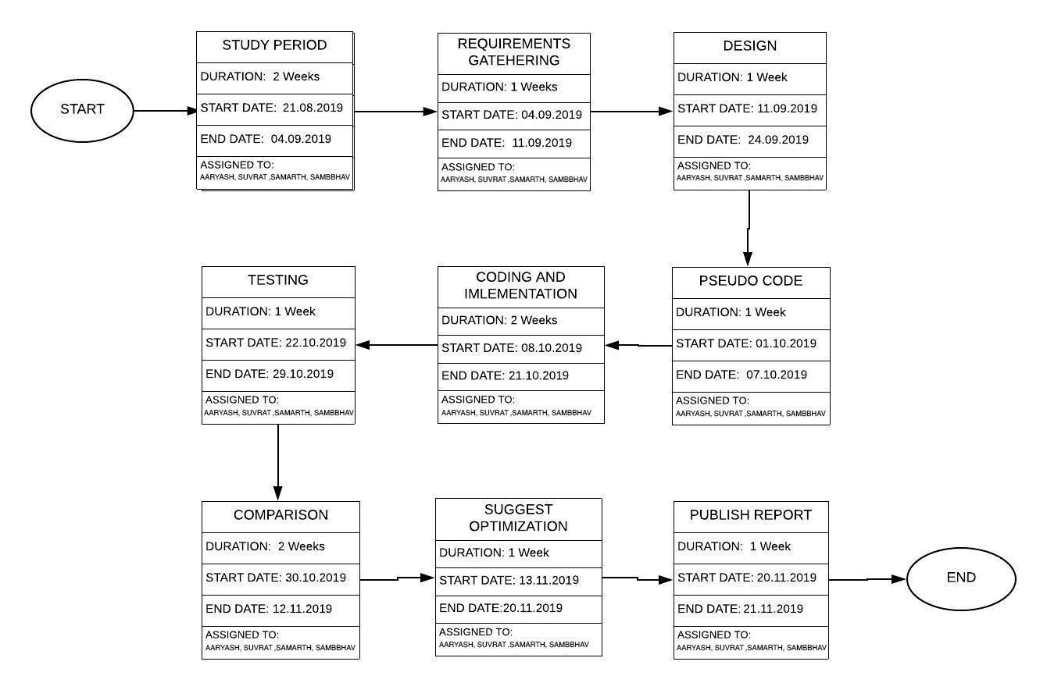

**REFERENCES**

[1] Kartik Rai, 2014 IJIRT | Volume 1 Issue 11| ISSN: 2349-6002 Lokesh Madan, Kislay Anand “Research Paper on Travelling Salesman Problem and it’s Solution Using Genetic Algorithm”

[2]Hasanen S.Abdullah, Ammar H.Jasim| November 2016| IJCSIS |vol 14, No.11

Improved Ant Colony Optimization for Document Image Segment.

[3]https://www.codecademy.com/articles/cf-cs-ridesharing

[4]Ravikiran Jaliparthi Venkat | December 13,2014 | PATH FINDING - Dijkstra’s Algorithm

[5]Ashok Kuppusam | August 2016 | A Literature Review on finding the K-shortest path using Dynamic Route Guidance Systems